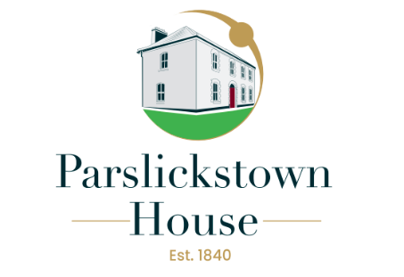
Job advertisement for the post of Community Centre General Manager

Name of Employer: Parslickstown House Management CLG.
Ladyswell Road, Base Enterprise Park, Damastown, Dublin 15
Job Title: Community Centre General Manager
Number of Hours: 39 Hours per week
Evening & weekend work may be a feature of this position.

Salary range: €45,000 - €59,000 (salary agreed will be dependent on experience)
Job type: Community Centre General Manager
Full-time (subject to funding)
Job Summary: (Job description available on request)
To work in partnership with the Voluntary Board of Directors (PHM CLG) staff and community leaders to follow through on aims, objectives and agreed areas of work outlined in the three-year strategic plan (2024 – 2027). The General Managers duties will include, but are not limited to the following:
- Manage the staff team and oversee the day-to-day management and operation of the House
- Facilitate the delivery of all programs and services operating in the house.
- Operate the house as social enterprise through the developing of new and existing initiatives.
- Access funding for new and existing programs will also be an ongoing part of the work to meet the demands and needs of the local community.
- Provide leadership in the organisation, ensuring its values and ethos are upheld.

Parslickstown House is a Company Limited by Guarantee with Charitable Status. The Community House is owned by Fingal County Council and is managed under a management licence by the Board of Directors of Parslickstown House Management CLG. This is a new position and is an exciting opportunity.

Essential Requirements for the Role
- A minimum of three years Management Experience is required within a community-based setting
- A 3rd level qualification in Business/Financial Administration, Community Development, Human Resources, facility management, Project Management, or Related disciplines. (Experience in lieu of qualification may be considered)
- Critical thinking and business development skills
- Excellent Communication and experience of interagency work
- Experience with financial systems and development of efficient systems to manage the finances of the company
- Experience in Human Resource Management through the provision of staff support, development and supervision are essential
- Have a good knowledge and understanding of the issues of poverty and social exclusion
- Proven experience in accessing funding. Experience in applying for grants/ funding or previous tendering experience an advantage

This position is 39 hours per week. Access to own transport and a full clean driving licence.

Please send CV and cover letter to:

The Chairperson

Address: Parslickstown House Management CLG
Ladyswell Road, Base Enterprise Centre, Damastown, Dublin 15
Email: parslickstownrecruitment@gmail.com

Closing date and time for receipt of applications is 5pm 24th Jan 2025

This project is an equal opportunities employer

Shortlisted applicants will be contacted only, as Parslickstown House Management CLG will not in a position to respond to a high level of submissions.
Applicants must provide a full disclosure for the purpose of Garda Vetting.

