**Fingal Public Participation Network**

**Nomination Form**

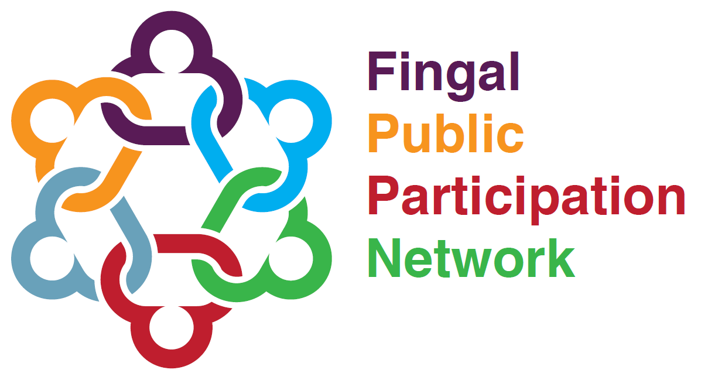

Application Form

Expressions of Interest for Vacancies for current vacancies.

|  |
| --- |
| **Secretariat Environment Seat Nomination (3 Vacancies)**  **Secretariat Dublin 15 (1 Vacancy)**  **Secretariat Balbriggan-Rush-Lusk-Swords (1 Vacancy)**  **Secretariat Social Inclusion Pillar Nomination (2 Vacancies)**  **LCDC Representative – Environment (1 Vacancy)**  **LCDC Representative – Social Inclusion (1 Vacancy)** |

*All applications received for the aforementioned vacancies will be considered at the next Plenary on 12th September 2024 when formal elections for vacancies are conducted.*

*If you need any assistance, please enquire at:* [*ppn@fingal.ie*](mailto:ppn@fingal.ie)

|  |  |  |  |  |  |
| --- | --- | --- | --- | --- | --- |
| **Fingal Public Participation Network: Secretariat Nomination Form** | | | | | |
| **Please complete this form in full and in BLOCK CAPITALS.** | | | | | |
| **1. Name of Nominee** | | | | | |
|  | | | | | |
| **2. Organisation of Nominee** | | | | | |
|  | | | | | |
| **3. Please select Vacancy by using x:** | | | | | |
| |  |  | | --- | --- | |  | **Secretariat Environment Seat Nomination (3 Vacancies)** | |  | **Secretariat Dublin 15 (1 Vacancy)** | |  | **Secretariat Balbriggan-Rush-Lusk-Swords (1 Vacancy)** | |  | **Secretariat Social Inclusion Pillar Nomination (2 Vacancies)** | |  | **LCDC Representative – Environment (1 Vacancy)** | |  | **LCDC Representative – Social Inclusion (1 Vacancy)** | | | | | | |
| **4. Contact Details** | | | | | |
| Address  (Including Eircode) | | |  | | |
| Email | | |  | | |
| Mobile | | |  | | |
| Phone | | |  | | |
| **5. What is the position you are being nominated for?** | | | | | |
|  | | | | | |
| **6. Can you confirm this nomination is being made in a voluntary capacity?** | | | | | |
|  | | | | | |
| **7. Have you read the brief attached associated with the position you are nominated for?** | | | | | |
|  | | | | | |
| **8. Do you understand the role you are nominated for?** | | | | | |
|  | | | | | |
| **9. Do you know of any potential conflict of interest in taking on this role?** | | | | | |
|  | | | | | |
| **10. Can you commit to the role you are nominated for?** | | | | | |
|  | | | | | |
| **11. Candidate Statement (Up to 150 words)**. State why you may be the most suitable candidate for the role. | | | | | |
|  | | | | | |
| **12. I have read the Code of Conduct and will sign up to fulfil this if elected.**  **If you are successful in this election and accept the position, you are deemed to have accepted to abide by the Rep Code of Conduct. Please find a copy of this Code of Conduct** [**here.**](https://fingalppn.ie/wp-content/uploads/2022/03/Appendix-6_Code_of_Conduct.docx) | | | | | |
| **Signature of Nominee** | |  | | **Date** |  |
| **13. Authorisation from Organisation of Nominee (Authorised Officer)** | | | | | |
| This nomination must be authorised by the nominee’s organisation. The Authorised Officer is the organisation’s Chairperson. If the Chairperson and Nominee is the same person, this nomination needs to be authorised by a different office holder. | | | | | |
| **Name** |  | | | | |
| **Position** |  | | | | |
| **Mobile** |  | | | | |
| **Email** |  | | | | |
| **Signature** |  | | | | |
| Thank you for filling in this nomination form. Please submit fully completed forms by 25th August 2024    **Email:** [ppn@fingal.ie](mailto:ppn@fingal.ie) **or**    **Hand:** Mark the envelope “Nominations, C/O Samantha Byrne, Fingal PPN” and drop into County Hall Swords or Civic Offices Blanchardstown **or**  **Post:** Nominations, C/O, Samantha Byrne, Fingal PPN, C/O Community Office, Fingal County Council, Civic Offices, Blanchardstown, Dublin 15.  For further enquiries email [ppn@fingal.ie](mailto:ppn@fingal.ie)    **Incomplete forms will be deemed invalid.** | | | | | |

**Fingal Public Participation Network**

Information / Brief Sheet: **Fingal PPN Secretariat**

|  |  |
| --- | --- |
| **Question** | **Answer** |
| **What is Fingal PPN** | The Fingal Public Participation Network is a network of community, voluntary, social inclusion and environmental organisations.  Our aim is to co-ordinate how the community in Fingal is represented. We also aim to:   * make our members stronger; and * keep our members informed about local developments.   **We help the community to be represented**  We work with the community so its representatives can take part in a fair and open way on a wide range of decision-making bodies. This includes:   * Fingal County Council; * local development companies; and * other local bodies.   We empower community groups to influence policy makers, like those mentioned above. |
| **What is the Secretariat** | The Secretariat is a board made up of 12 members elected by the Plenary. The Secretariat meets each month and is responsible for overseeing the day-to-day running of the PPN. They manage the staff, budget and operations, and report back to the plenary meeting. |
| **Vacancies** | * Secretariat Environment Seat Nomination (3 Vacancies) * Secretariat Dublin 15 (1 Vacancy) * Secretariat Balbriggan-Rush-Lusk-Swords (1 Vacancy) * Secretariat Social Inclusion Pillar Nomination (2 Vacancies) * LCDC Representative – Environment (1 Vacancy) |
| **Skills and knowledge required from the representative** | **N.B. – Your organisation must be part of the specific pillar in order to nominate an individual for election in that pillar.**  There is no such thing as an ideal candidate. We need all types of people with all types of interests and skills involved in our Secretariat.  All successful candidates will receive and induction to the Secretariat and support to fulfil their role.  We do not have requirements, except that you are a PPN member. Outside of that, it would be ideal if you had an interest in:   * managing a work plan; * developing policies and procedures; * empowering communities; * working with people; and * challenging the status quo. |
| **Position Duration of term** | Approximately 3 years. |
| **Number of meetings the representative is required to attend per year** | **Required meetings per year:**  10 Secretariat Meetings (monthly except August and December)  2 Plenary Meetings (May and November)  **Other potential commitments:**  Secretariat subgroups  Regional Meetings  Training and Information Settings/ Team Building Sessions |
| **Meeting Details** | **Secretariat Meetings**   * Location: Meetings alternate between Fingal County Council Offices – County Hall Swords or Civic Offices Blanchardstown * Time: 7pm * Meeting Duration approx.: 1.5 to 2 hours.   **Plenary Meetings**   * Location: Meetings Alternate locations around the county * Time: Evening * Meeting Duration: 2.5 – 3 hours |
| **Code of Conduct** | If you are successful in this election and accept the position, you are deemed to have accepted to abide by the Rep Code of Conduct. Please find a copy of this [Code of Conduct here](https://fingalppn.ie/wp-content/uploads/2022/03/Appendix-6_Code_of_Conduct.docx). |
| **Email** | Agree to share email address with the other sitting secretariat members. |

**For More Information**

Contact Fingal PPN by email on [ppn@fingal.ie](mailto:ppn@fingal.ie)

**Fingal Public Participation Network**

Information / Brief Sheet: **Fingal PPN LCDC Representative**

|  |  |
| --- | --- |
| The Fingal Public Participation Network is a network of community, voluntary, social inclusion and environmental organisations and we are active in the Fingal County area. Fingal County is located north of Dublin City and Lucan. It covers the north of County Dublin, including areas such as Castleknock, Howth, Swords, Balbriggan, Blanchardstown, Rush and Lusk. Our members are people like you who work in the community. Our members’ involvement in our activities makes us strong and effective.  Our aim is to coordinate how the community is represented. We also aim to:   * make our members stronger; and * keep our members informed about local developments. | |
| **1. Name / Title of Board / Organisation** | |
| **Fingal Local Community Development Committee** to include the **Dublin Rural LEADER Local Action Group** | |
| **2. Function / Scope of the Board** | |
| The Local Government Reform Act 2014 gives legislative effect to the commitments in ‘Putting People First’ including the establishment of LCDC’s in each local authority administrative area, for the purposes of developing, co-ordinating and implementing a coherent and integrated approach to local and community development. | |
| **3. Who else (agencies / orgs) sits on the Board?** | |
| Fingal County Council Elected Members, Fingal County Council, Fingal Local Enterprise Office, TU Dublin, Fingal Dublin Chamber of Commerce, Dept of Social Protection, Fingal CYPSC, HSE, North Dublin Regional Drug and Alcohol Task Force, Irish Farmers Association, Empower, Fingal LEADER Partnership. Fingal PPN. | |
| **4. The role of the LCDC** | |
| **The role of the LCDC**  The role of the LCDC will drive meaningful citizen and community engagement in the scoping, planning, delivery and evaluation of local and community development programmes.  Successful representatives will assist:   * Co-ordinate, manage and oversee the implementation of local community development programmes including the Government’s Social Inclusion Community Activation Programme (SICAP), LEADER and pursue opportunities for additional funding whether exchequer, EU, private or other sources. * Prepare and arrange for the implementation of the community element of a six year Fingal Local Economic and Community Plan (LECP), consider and review the economic elements. * General development including enterprise and economic functions arising from local and community development activities including social enterprise. * A clear focus on social inclusion & marginalised communities   The LCDC Linkage Group will work along a sub set of the three Electoral College model  The role of the FCN representative on LCDC is to represent the views of LCDC Linkage Group not their own organisation. Specifically, the role is to bring issues of relevance from the Linkage Group to the LCDC and give feedback to the Linkage Group, Electoral College and /or the County Plenary as appropriate on the outcomes of meetings and the issues being raised | |
| **4. What is the Commitment?** | |
| How many meetings / how often | LCDC is 6 Meetings per year, Dublin Rural LEADER LAG is 6-8 Meetings per year. |
| Location of meetings | TBC |
| Time of meetings (day / evening) | TBC |
| Does this position require becoming a company director (yes/no) | No |
| Is there potential subgroups involved? | Yes |
| Term of Office? | Maximum 6 Years |
| **5. Who are you looking for?** | |
| How many representatives do you want? | 1 Vacancy |
| Which Pillar / Sector do you want a representative from? (Community/Voluntary, Environment or Social Inclusion) | * Environment x 1 |
| What skill set / interests should the representative (ideally) have? | Environment/Climate Action |
| Anything else? | Environment Rep for Fingal LCDC positions, this vacancy is also linked to corresponding vacancies on the Dublin Rural LEADER Local Action Group, so there is a requirement to participate as full members on both committees. |