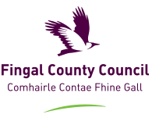

**Draft Fingal Climate Action Plan**

**2024-2029**

**Youth Climate Action Survey**

#ClimateAction



**Fingal County Council would like to hear your views on Climate Change**

**Please Scan the QR Code below**



**To view the Draft Climate Action Plan and submit comments/ observations scan this:**

