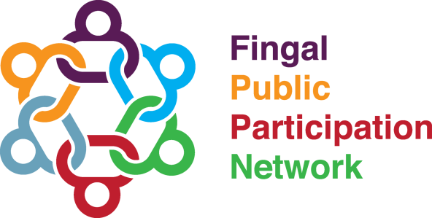
Minutes
Linkage Group Name | Social Inclusion, Rural Development, Youth and Enterprise
Venue | Zoom Video Conferencing Meeting
Date of Meeting | 16th August 2022 7.00 to 8.30 pm
Attendees | Facilitator: Esther Onolememen  Maire O'Brien, Esther Onolememen, Myles Caulfield, Elisa Sperati, Geraldine Rooney, Olanike Adesemowo, Alice Davis, Helen Mobit, Anthony Brennan, Leina Ibnouf, JK Onwumereh, Yetunde Joyce, Esther Ade  Apologies: Lawrence Carvalho
In attendance | Adam Rudden (PPN Support Worker)
- Open, Introductions and Minutes
Facilitator opened the meeting and started with round of introductions.

- Social Inclusion Week Presentation – Fingal Integration Officer
Valerie McAllorum Byrne (Fingal Integration Officer) gave a presentation on Fingal Inclusion Week 2022
- Linkage group inquired whether Phoenix FM is the only local radio station promoting Fingal Inclusion Week e.g. Saint Ita's Radio.
  - Fingal Integration Officer stated thar Phoenix FM connected them. No other community radio stations have made contact. The Fingal Integration Officer communicated that when they attended National Community Radio Day in June that Phoenix FM was the only community radio station present.
  - Linkage Group members stated that they found it hard to categories their group (Balbriggan Meals on Wheels) with the given category choices as part of the Social Inclusion Week Presentation expression of interest. Their work is not limited to “Older People.”
Fingal Integration Officer stated there was a space on the form for participants to clarify there category choice.
- Linkage Group Member highlighted the importance of a category that includes awareness of poverty.
  - Fingal Integration Officer mentioned that community groups working to reduce poverty will also be participating in the week. The reason it is not an explicit category is to respect/maintain the privacy of those experiencing poverty.
- Linkage Group discussed how to category of “Migrants” was especially important due to the context of Ukrainian Refugees.
  - Fingal Integration Officer communicated that the Community Office has hired a Community Officer to work solely with Ukrainian Refugees and that they will be included in Social Inclusion Week.
- Linkage Group mentioned that it might be worthwhile contacting Anne Cassin from National Wide. Even though publicity for this event is kept locally to Fingal, Nationwide have featured areas in Fingal before.
- Previous Meeting Minutes
Minutes proposed by AD
Seconded by OA
No issues arising.
- Youth
PPN Support Worker informed Linkage Group that Fingal Comhairle na nOg were not available to participate in this round. The aim is to have them present at Round 4 of the linkage Group.

PPN Support Worker informed Linkage Group that a new Foróige Balbriggan Digital Youth Hub has been launched.

- Inclusion: Let’s Play Rush
PPN Support Worker informed linkage group that “Let’s Play Rush” has been holding a number of play events under the EU URBACT project called Playful Paradigm.

Linkage Group Member discussed that Rush Men’s Shed participated in the event and it was very successful.

- Rural: Tidal pool feasibility Study Balbriggan Fingal County Council
PPN Support Worker informed linkage group that Fingal in undertaking a Tidal pool feasibility Study Balbriggan.
- Linkage Group member stated that accessibility be a key part of the feasibility study.
- Linkage Group inquired about a previous PPN motion in relation to extending the seasons life guards will on duty to provide for all year round swimmers.
  - Marine & Coastal Management SPC Rep will bring motion to Climate Change, Environment and Water Linkage for submission to SPC.
  - MC will draft up motion.
- Linkage group member communicate the need to have swimming lesson programmes for young people and migrants. Not every primary school/secondary school has swimming programmes for young people. Linkage Group member mentioned how the tragedy around Bradley Lulendo death emphasised the importance of this.
  - Linkage Group to write to Linkage Group to write to the Sports Officer inquiring about their Swimming programme activities.
  - the Sports Officer inquiring about their Swimming programme activities.

Enterprise: LEO (Local Enterprise Office)
PPN Support Worker informed group about of a number of events LEO IS holding:
- Start Your Own Business - Tuesday 23rd August 2022
- Lean for Micro Programme Informational - Thursday 1st September 2022
- Tax & VAT for Beginners - Wednesday 7th September 2022
Community Issues
Linkage Group Member inquired about an update on the LECP plan as there has been a delay.
LCDC Rep Geraldine Rooney will seek an update at the next LCDC Meeting.
Next Meeting
Date: TBC

