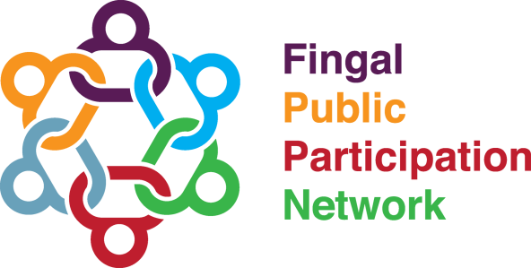
Arts, Community, Heritage and Sports Linkage Group
2nd June at 7pm
Zoom
Linkage Group Business

Open, Introductions and Minutes
Representative Report
Nominee Statements
Community & Voluntary Seat – 4 Nominees
- Elisa Sperati - Friends of D15
- Yetunde Joyce - Loving and Affectionate Family
- Abimbola Wise - Children4WorldChildren
- Áine O'Beirne – Balbriggan Community Council

Social Inclusion Seat – 1 Nominee
- Kesava Gollapalli - Fingal Ethnic Network
Final Consultation on the draft of the Second SDG National Implementation Plan 2022-2024
Discussion on Community Issues - Breakout Rooms
Agreement on actions / issues to be pursued
AOB and Close

