Timetable for International Women’s Day ( these times are approximate)

Zoom link

https://us02web.zoom.us/j/89137163993?pwd=WWdIVzdJVldUekFSVGcxQTF2elZKdz09

1.45pm – Zoom Waiting room opens
2.00pm – Welcome and – Opening by Mayor of Fingal Seána O Ródaigh
2.05pm - Margaret Godwin plays “Mná na hḖireann” on the flute
2.10pm - Mairead Dempsey is in conversation with Dr. Annie Curtis – Immunologist and Body Clock expert on the importance of sleep to our immune system and our mental wellbeing.
2.30pm – Marian Neary reads her poems ““The Secondhand Book” and “Thin Air”.
2.35pm - Catherine Connolly, Aromatherapist Fern Therapies demonstrates how to make a cooling spray and cream for the menopausal moments.
2.50pm – Denise O’Toole sings “Bread and Roses”
2.55pm – Mary Farrell is in conversation with Rosemary Hennigan author of “The Truth Will Out”. Rosemary qualified as a lawyer and had had an interesting career as policy co-ordinator with Focus Ireland and has campaigned with Home for Good to secure a referendum on the Right to Housing.

3.15pm – Rose from Fingal gives her humourous view of life.
3.20pm - “A Chat with the Girls” – Debbie Breslin has an intergenerational conversation with three women and gets their views on modern life.
3.30pm – Erin McGahan plays “Eleanor Plunkett” on the violin.
3.35pm. Debbie Breslin reads “Let Her Breathe” a poem by Becky Hemsley.

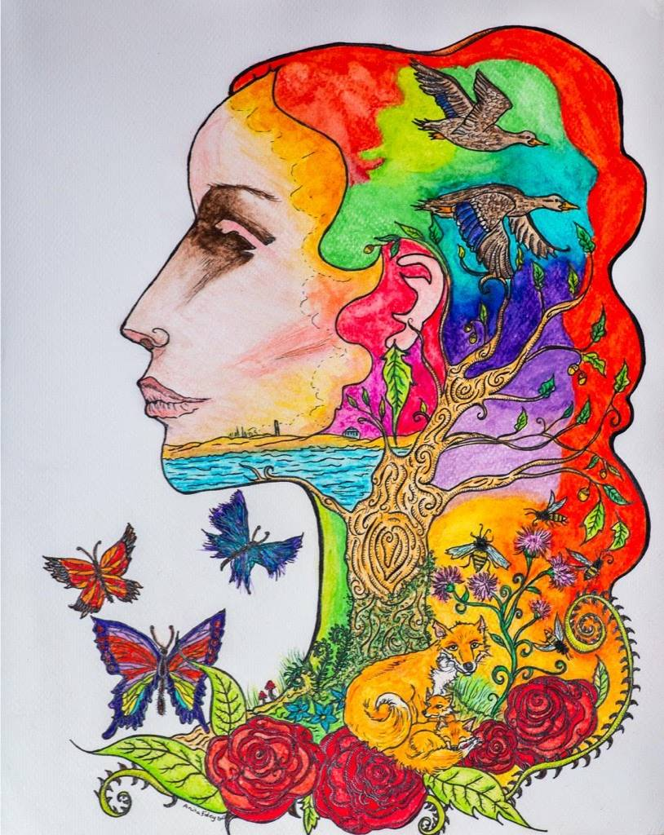
“Mnά na Leithinse” by local artist Anita Foley

