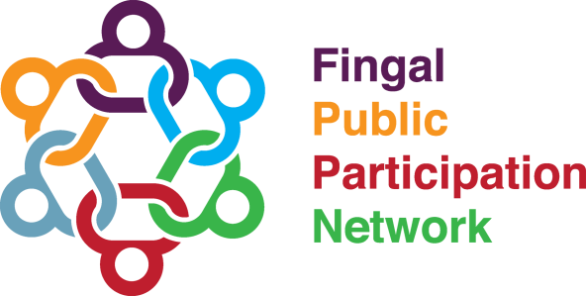
Community Safety, Crime and Policing Linkage Group Meeting
3rd February 2022 at 7pm – 8.30pm Zoom
(TBC)
Linkage Group Business

- Open, Introductions and Minutes
- Representative Report
- Workplan
- Specific Linkage Group Funding for a project
- Linkage Group Training (For Facilitator, Representatives, and wider Linkage Group Members)
- An Garda Síochána Launch KOPS (Keeping Our People Supported) - The New Garda Wellbeing App - 16th November 2021:
- Discussion on Community Issues - Breakout Rooms
- Agreement on actions / issues to be pursued
- AOB and Close

