Fingal Public Participation Network

Nomination Form

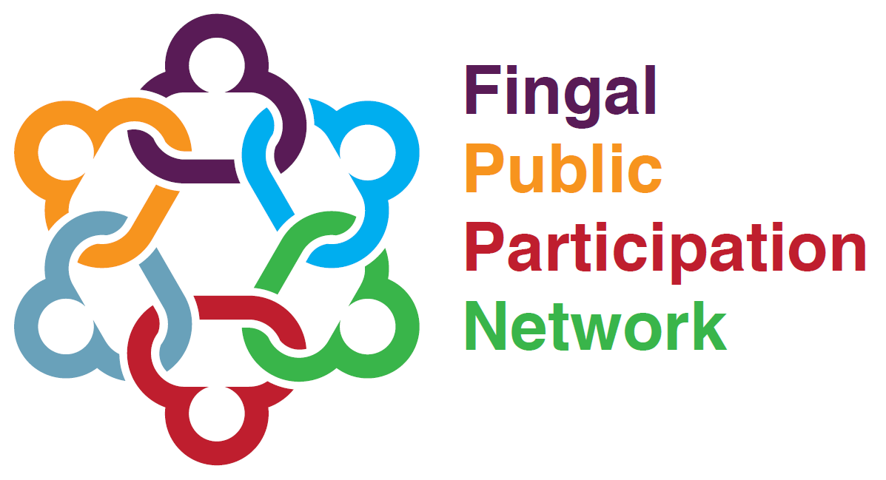

Housing SPC Representative

Deadline: 4.00pm 15th April 2021

Fingal Public Participation Network: Housing Nomination Form
Please complete this form in full and in BLOCK CAPITALS.
1. Name of Nominee
2. Organisation of Nominee
3. Pillar of Nominee (Community & Voluntary, Environment or Social Inclusion)
Social Inclusion
4. Contact Details of Nominee
Address (Please include Eircode)
Email
Mobile
Phone
5. What is the position you are being nominated for?
Representative Housing SPC
6. Can you confirm this nomination is being made in a voluntary capacity?
7. Have you read the brief associated with the position you are nominated for?
8. Do you understand the role you are nominated for?
9. Can you commit to the role you are nominated for?
10. Candidate Statement (Up to 150 words) This will be circulated to members ahead of the election. State why you may be the most suitable candidate for the role.
Please note Fingal PPN is bound by the Freedom of Information Acts legislation.

11. I have read the PPN Rep Charter and will sign up to fulfil this if elected.
Signature of Nominee |  |  |  | Date
12. Authorisation from Organisation of Nominee (Authorised Officer)
This nomination must be authorised by the nominee’s organisation. The Authorised Officer is the organisation’s Chairperson. If the Chairperson and Nominee is the same person, this nomination needs to be authorised by a different office holder.
Name
Position
Mobile
Email
Signature
Thank you for filling in this nomination form. Please submit fully completed forms by
Email: ppn@fingal.ie or
Hand: Mark the envelope “Nominations, C/O Laura Barton, Fingal PPN” and drop into County Hall Swords or Civic Offices Blanchardstown or
Post: Nominations, C/O, Laura Barton, Fingal PPN, Community, Culture & Sports Division , Fingal County Council, Civic Offices, Blanchardstown, Dublin 15.
For further enquiries email ppn@fingal.ie or call 087 0952737
Incomplete forms will be deemed invalid.

