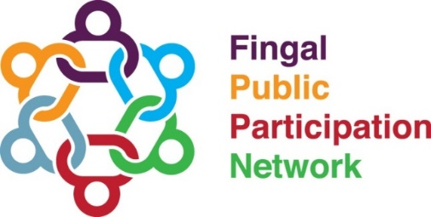

Zoom User Guide

Joining the Meeting
The meeting will be available to join from 6.50pm to provide ample time to iron out any issues you may have with joining.

To join the meeting, please Ctrl + click on the following link:

The following page will open on your browser and will prompt you to open the Zoom app.
Click ‘Open Zoom’.
If the pop up does not appear, click ‘launch meeting’.
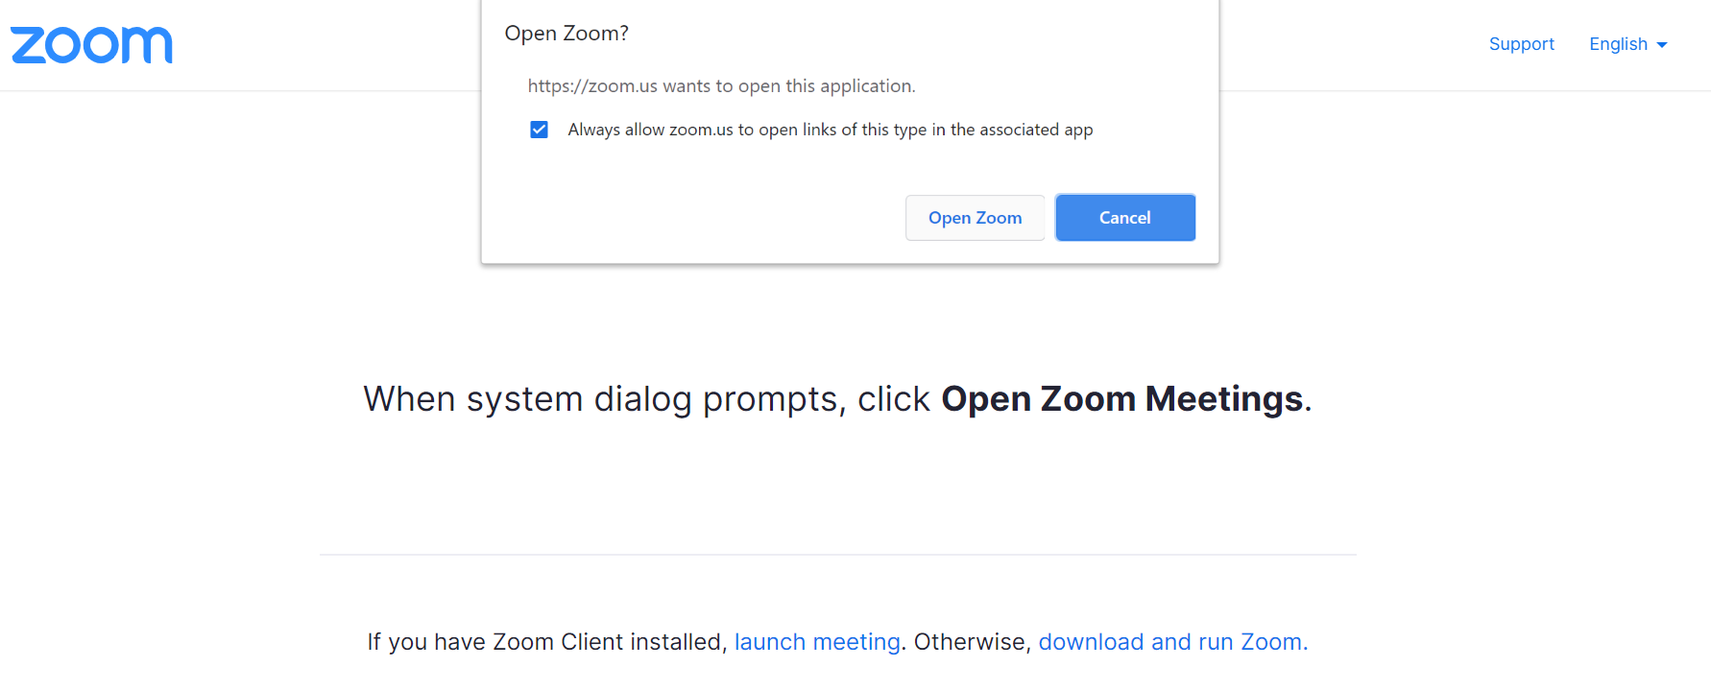
If you do not have Zoom downloaded, click ‘download and Run Zoom’.
Once the app has downloaded, click ‘launch meeting’.
When you join the meeting, you will be shown the following pop up and prompted to select ‘join with Computer audio’, which will let you hear and speak in the event. Click ‘join with Computer audio’.
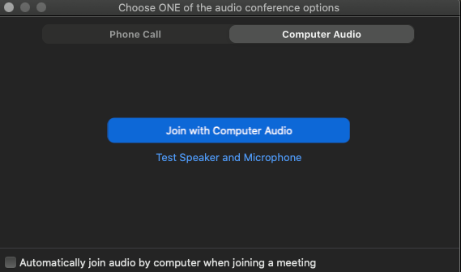

Basic Functions
Muting Audio
All participants will be on mute when they join the meeting. We ask that participants stay muted throughout the event except for when they are taking part in the networking group session, question and answer session or Plenary session. Participants are muted when there is a line running across the microphone icon as shown in the image below.
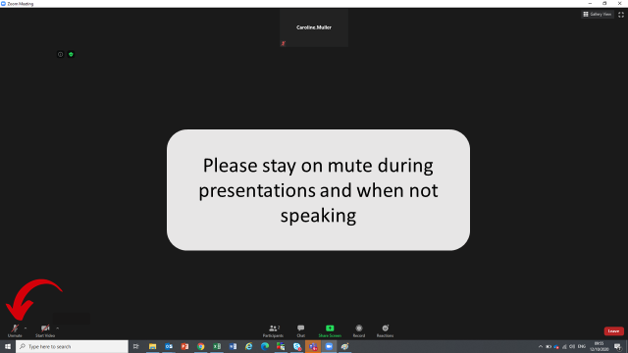

Unmuting Audio:
Participants can unmute themselves when they are taking part in the networking group session and Q & A sessions by clicking on the microphone icon, which will remove the line running across the microphone icon as shown in the image below.
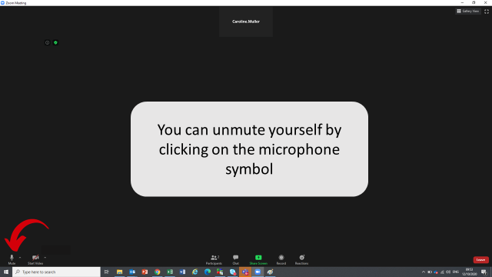
Turning on and off Video
You can turn on and off your video as you so wish throughout the event. In order to turn on your video, please click on the video icon which is located next to the mute icon. When your video is off there will be a line running though the video icon as seen in the image below.

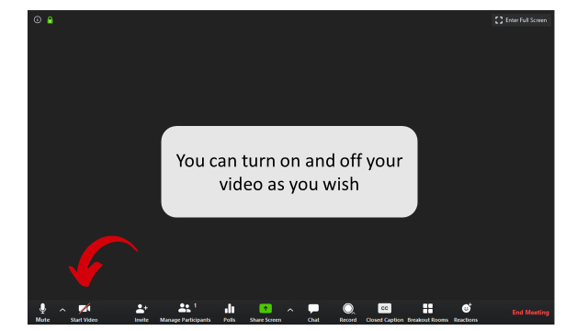

Chat Function
You can use the chat function to note any IT issues that you are experiencing or to input questions at the end of the event. To access the chat function, please click on the chat icon as shown below.
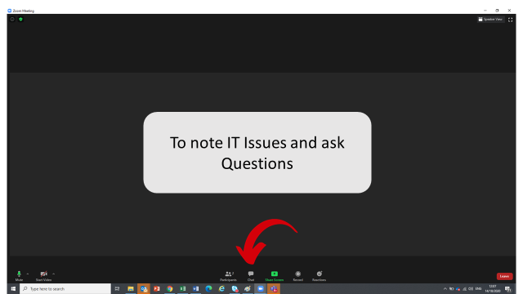

This will then bring you to the dialogue box on the right of the screen where you can input your IT issue or question as shown below.
