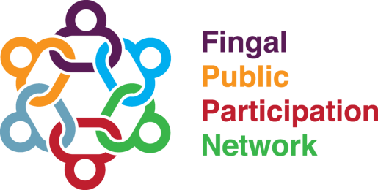
DRAFT: Fingal PPN Plenary Meeting Minutes | 06th November 2019 | Carnegie Court Hotel
Open and Welcome
The plenary was opened by Michael Walsh.
Minutes were proposed by Claire Ann Ferry and seconded by Heidi Bedell, with no matters arising.
The plenary was preceded by the launch of Fingal Inclusion Week (presentation from Michela Benassi and Anthony Onwuka, Fingal Inclusion Week Steering Committee) and the launch of Fingal Community Directory at www.fingalcommunitydirectory.ie. (Presentation from Denise McDermott)
Current PPN Resource Worker’s Departure
In a slight change to the Agenda, John Melvin paid tribute to Jamie Moore on behalf of the Secretariat, acknowledging his importance in the development of Fingal PPN, making it one of the country’s leading PPNs. Jamie will finish working with the PPN by the end of 2019.
PPN Activity Report
Claire Ann Ferry and Kathleen McCann provided progress reports on PPN Activity and on the Linkage Groups.
- PPN Progress and Achievements in 2019 includes Fingal Inclusion Week, National Community Weekend/The Big Hello, Africa Day, Communities4Envirnoment Competition, 5 PPN Representatives on LCDC, and 3 PPN Representatives on LEADER local Action Group.
- In 2019, Fingal PPN had policy and programme input on a number of key strategies including: Broadmeadow Way, Dublin Airport Local Area Plan, Fingal Climate Change Action Plan, FCC Strategic Policy, FCC Corporate Plan, Fingal Digital Strategy, Fingal Community, etc.
- PPN redesigned website which included Micro-sites for Linkage Groups, new Resource Section, information that improves governance and transparency, and an Events and Calendar Section.
- In 2019, there are 13 New Strategic Policy Committee Representatives, 6 New Joint Policing Committee Representatives, 23 Linkage Group Meetings, and 5 Linkage Group Facilitators.
- In 2019, 83% of Fingal PPN Members have seen their insurance cost rise. 35% of members are in danger of closing due to insurance cost. Fingal PPN continues to advocate for reform on the issue of insurance.
- The draft budget was proposed and passed. As were the updates on the local PPN and changing places.
- The Linkage Group update provided information on the activity of each of the Linkage Groups and the new PPN Representatives who have been nominated by each.
Motions:
Motion 1: Propose a pilot of local area based PPN in the Lusk area to take place 2020 – Passed
Motion 2: Continued to advocate for and include Changing Places in relevant submissions. – Passed.
Motion 3: Fingal PPN Plenary now adopts the constitutional amendments as recommended by the PPN Constitution Steering Committee (following a presentation from Angela Rogers and Doreen Keaney) – Passed
Plenary Session
During the plenary session, the following was discussed:
- Clarification around the annual hosting charge paid by the PPN.
- The significant programme budget of Fingal PPN relative to other PPNs. Fingal PPN has the largest programme budget of all PPNs across Ireland.
- The make-up of Strategic Policy Committees and in particular, the Environment seats.
- Measuring the work and impact of the PPN, and if the Linkage Groups are making a difference.
- Further tributes to PPN.
Close of Plenary
Michael Walsh brought the Plenary to a close.

